CSC 2400

Homework 1 - Key
- Show the execution of method EuclidGCD(14300, 5915) by constructing a table similar to Table 1.1.1.
a b
14300 5915
5912 2470
2470 975
975 520
520 455
455 65
65 0

EuclidGCD(14300, 5915) = 65

- (use pseudocode)
Non-recursive algorithm for EuclidGCD(a, b)

ALGORITHM EuclidGCD(a, b)
//calculates the gcd of two numbers using a non-recursive (iterative) method
// Input: Nonnegative integers a and b, not both 0
// Output: The greatest common divisor of a and b
while b ≠ 0 do
r ← a mod b
a ← b
b ← r
return a

- What does Euclid’s algorithm do for a pair of integers in which the first is smaller than the second? What is the maximum number of times this can happen during the algorithm’s execution on such an input?

Switches the order of the 2 numbers, such that the bigger one becomes first. It can only happen a maximum of 1 times.

- Write an algorithm in pseudocode for each description of the input and output.

(a)
Input: a1, a2, …, an, a sequence of numbers, where n>=1,
n, the length of the sequence.
Output: "True" if the sequence is non-decreasing and "False" otherwise.

A sequence of numbers is non-decreasing if each number is at least as large as the one before.
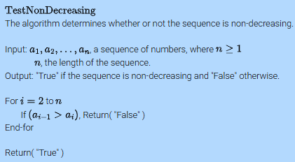
(b)
Input: a1, a2, …, an, a sequence of numbers, where n>=1,
n, the length of the sequence.
Output: "True" if the sequence contains two consecutive numbers that are the same and "False" otherwise.
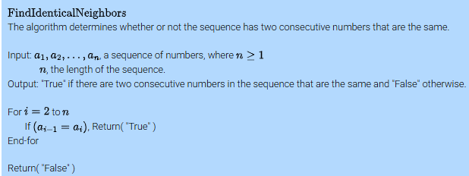
(c)
Input: a1, a2, …, an, a sequence of numbers, where n>=1,
n, the length of the sequence.
Output: "True" if any two numbers in the sequence sum to 0 and "False" otherwise.
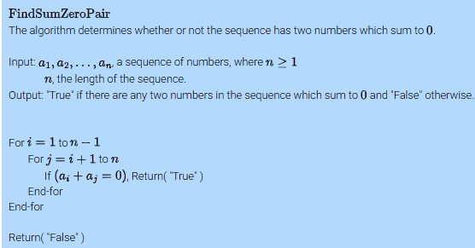
(d)
Output: "True" if the sequence has any three numbers that form a Pythagorean triple.

The numbers x, y and z are a Pythagorean triple if x² + y² = z².
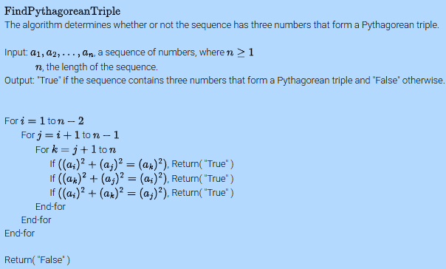
(e)
Input: a1, a2, …, an, a sequence of numbers, where n>=2,
n, the length of the sequence.
Output: The second smallest number in the sequence.
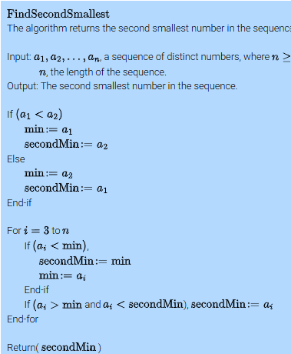

- 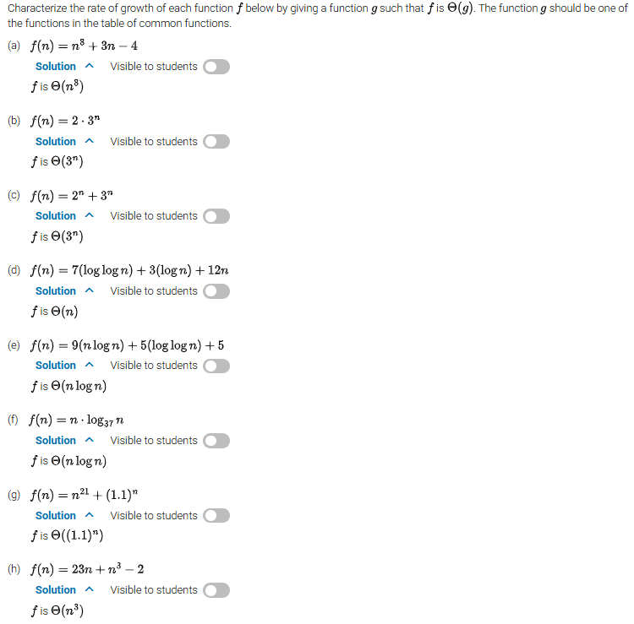

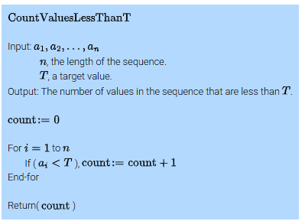
Characterize the asymptotic growth of the worst-case time complexity of the algorithm. Justify the answer.
Basic operation: comparison in the for loop.
The number of iterations of the loop is n, regardless of the input sequence. The worst-case complexity is Θ (n)

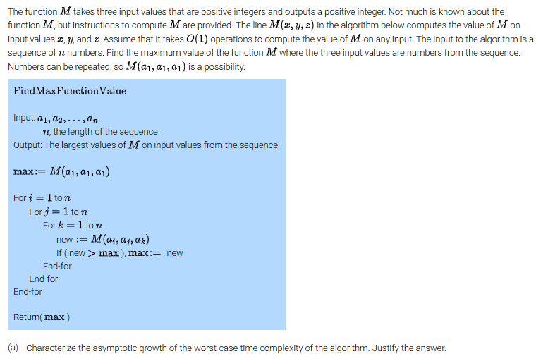
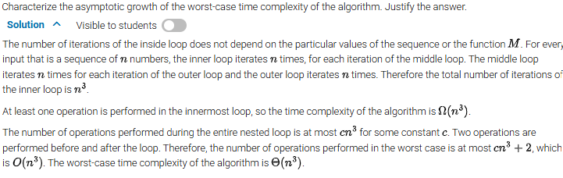

- Why shouldn’t we measure time efficiency based on the number of seconds or milliseconds it takes the algorithm to run?
We should not measure time efficiency based on the number of seconds or milliseconds because that depends on too many external factors such as the speed of the computer, the programming language used, how optimized the code is, or even what else is running on the machine. Instead, we focus on how many (basic) operations the algorithm performs relative to the input size — that gives us a better, machine-independent way to compare algorithms. That's why we use things like Big-O or Big- Θ notation to describe the algorithm’s time complexity.

- The ______time complexity__________________________________ is characterized by the number of times the most important operation of the algorithm occurs.

- Find the binary representation of the following numbers:

NUMBER BINARY REPRESENTATION (in bits)
777
14
684,739
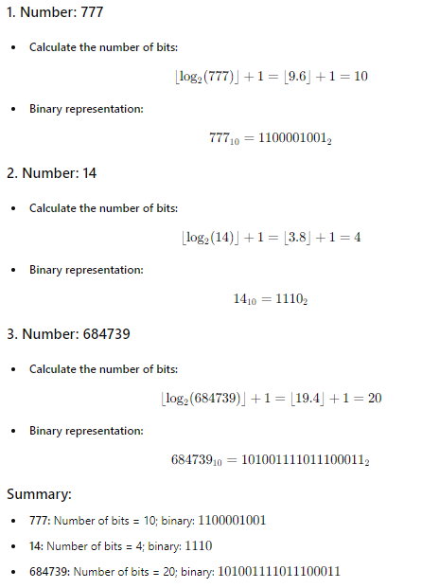
- Write the input size metric and the basic operation of the following algorithms:

ALGORITHM INPUT SIZE BASIC OPERATION
Computing the sum of n numbers n addition
Computing n! log₂n multiplication
Finding the largest element in a list of n numbers n comparison
Euclid’s algorithm magnitude of m + magnitude of n % (mod)

12. Explain this formula: T(n) ≈Cop * C(n )
a. What is this formula calculating?
T(n) is running time of an algorithm
b. What is Cop?
C_{op} is the execution time of n algorithm’s basic operation, characteristic for the computer used (hardware, network, time, other processes running, etc)

c. What is C(n)?
C(n) is the number of times the basic operation is executed
There was a typo here; I will give you credit if explaining n only

- What is ORDER OF GROWTH?
Order of growth is the asymptotic behavior ( as n -> infinity) of the algorithm's running time as the input size grows.
- For each of the following functions, indicate how much the function’s value will change if its argument is increased fourfold. HINT: Use either the difference between or the ratio of f(4n) and f(n) whichever is more convenient for getting a compact answer. If it is possible, try to get an answer that does not depend on n.
FUNCTION FUNCTION INCREASED BY MAGNITUDE of 4
log₂n (HINT: log₂4n) log₂4+log₂n = 2+log₂n (increase by 2)
n^{1/2} (4n)^{1/2} =4 ^{1/2} n^{1/2}= 2*n ^{1/2} (2 fold increase)
n 4n (4 fold increase)
n² (4n) ²= 4 ² * n² = 16n² (16 fold increase)
n³ (4n) ³= 4 ³ * n³ = 64n³ (64 fold increase)
2^{n} 2 ^{4n} = (2n)⁴ (a (2^{n})³ fold increase)

- For each of the following pairs of functions, indicate whether the first function of each of the following pairs has a lower, same, or higher order of growth (to within a constant multiple) than the second function.
FUNCTION lower / same/ higher growth rate

n(n+1) and 2000n² same

log₂n and ln(n) use log_{a} n= log_{a} b* log_{b}n; same

log₂ ²n and log₂n² log₂ ² n = log₂n log₂n, and log₂n² = 2 log₂n. higher

2^{n-1} and 2^{n} same (use 2^{n−1} = (1/2) *2^{n})

(n-1)! and n! (n − 1)! has a lower order of growth than n!=(n − 1)!n

- For each of the following functions, specify the lowest Big-Oh complexity of each algorithm (largest order of growth):
Expression O(…)
EXAMPLE: 5 + 0.001n³ + 0.025n O(n³ )
0.3n + 5n ^{1.5} + + 2.5n ^{1.75} O(n ^{1.75}) or higher order
nlog₃n + nlog₂n O(nlogn) or higher order
100n + 0.01n² O(n²)
0.01nlog₂n + n(log2n)² O(n(log n )²) or higher order (check next page)
